PRODUCT DESCRIPTION

# Product Title

# Self-driving car renting service

# Product Scope

**Product functionality**

Our products have the following functions:

+ Specify the date and time you want to rent

+ Select the vehicle you want to rent

+ Cancel the car what I book

+ Know the rent of car and have receipt payment

+ View car booking history

+ Extension of time or date of booking a car

+ Choose the nearest garage for customers to come and pick up the car

**Users**

Website users include:

The user will determine the rental period, view vehicle information.

We cooperate with people who have a car and they want to rent it out

We rent out garages to park cars when no one is rented, and the staff in those garages clean the car, reporting it's condition.

**Objectives**

The purpose of the app is to help us find the right vehicle to go out, travel or organize at weddings. User can also choose the time of booking the car. User can locate the nearest garage to your house.

# Stakeholders

## Customers

## Supply vehicles

## Vehicle maintenance

* Car-rental Staff

# Functional Requirements

|  |  |  |
| --- | --- | --- |
| Requirement # | Description | Related Requirements |
| FR1: actor:User |  |  |
| FR1.1 | The system must allow customer to register for reservation. |  |
| FR1.2 | The system must allow customer to view detail information of particular car. |  |
| FR1.3 | The system must notify on selection of unavailable cars while reservation. |  |
| FR1.4 | The system must view list of available car during reservation. |  |
| FR1.5 | The system shall allow the customers to cancel their reservation using reservation confirmation number. |  |
| FR1.6 | The system shall present an option for advanced search to limit the vehicle search to specific categories of vehicles search.E.g. By Brand, Type and Model. |  |
| FR1.7 | The system shall allow the customers to extend their reservation when their reservation is due. |  |
| FR1.8 | The system shall allow the customer to choose their nearest garage for them to pick up their vehicle. . |  |
| FR1.9 | The system shall allow the customers to view their reservation history . |  |
| FR1.10 | The system must be able to display reservation summary for successfully committedreservation |  |
| FR1.11 | The system must display a commitment to information and product quality that is the same as what was ordered. |  |
| FR1.12 | The system must provide a payment option for customers |  |
| FR2: actor: Staff |  |  |
| FR2.1 | The system shall allow staff to view reservations made by customers. |  |
| FR2.2 | The system should allow staff to register new cars. |  |
| FR2.3 | The system shall allow staff to select cars in the list |  |
| FR2.4 | The system shall allow staff to update information of the car in need of modification. |  |
| FR2.5 | The system shall allow staff to display all lists of car |  |
| FR2.6 | The system shall allow staff to cancel the booking of customers into rental list. |  |
| FR2.7 | The system shall allow staff to display all rented car. |  |
| FR2.8 | The system shall allow staff to display all off duty car. |  |
| FR2.9 | The system shall allow staff to update about customer rent record details in the rentallist. |  |
| FR2.10 | The system shall be able to save all changes made on the customer rent list. |  |
| FR2.11 | The system shall allow staff to select customer rent record by specific search category |  |
| FR2.12 | The system shall allow staff to display customers, who rent cars. |  |
| FR2.13 | The system shall allow staff to display all customers rent record. |  |
| FR2.14 | The system shall presents information on protection products and their daily costs,and requests the customer to accept or decline regulation terms during reservation. |  |
| FR2.15 | The system will have constant updates on the specific location of the cars. |  |
| FR3:actor: Car Owner |  |  |
| FR3.1 | The system will allow car owner to register a new vehicle. |  |
| FR3.2 | The system will allow the car owner to cancel a car on the rental list. |  |
| FR3.3 | The system will allow the car owner to update a car on the rental list. |  |
| FR3.4 | The system will allow the car owner to display all lists of cars on the rental list. |  |
| FR3.5 | The system must display a commitment to protect the property of the car owner. |  |
| FR3.6 | The system allows the car owner to receive the location of the car from the system |  |
| FR4:actor: garage owner |  |  |
| FR4.1 | The system allows the garage staff to open the vehicle maintenance status |  |
| FR4.2 | The system allows garage staff to take pictures of the location of the vehicle that needs maintenance. |  |
| FR4.3 | The system allows the garage staff to record the car's condition when the customer returns the car to the garage. |  |

Use case diagaram

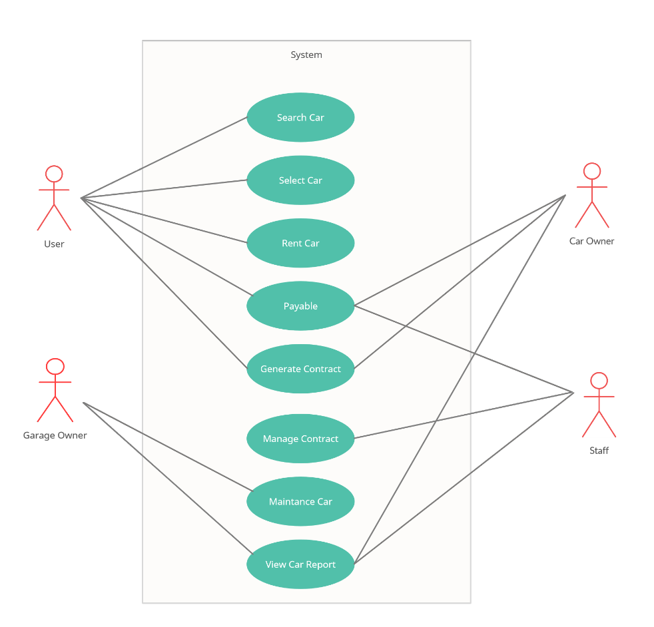

# Non-functional Requirements

**Non-functional requirements** are requirements that are not directly concerned with the specific services delivered by the system to its users. They may relate to emergent system properties such as performance, availability, and security, etc.

## Targeted Platforms

The system is available as a web service so customers and users can easily access and manage their rented vehicles via web browser, mobile app.

## Usability

- The system provides a help and support menu in all interfaces for the user to interact with

the system. The user can use the system by reading help and support.

## Performance

- The system response time for every instruction conducted by the users/customers must not exceed more than a minimum of 10 seconds.

## Availability

- The system should always be available for access at 24 hours, 7 days a week.

- In the occurrence of any major system malfunctioning, the system should be available in 1 to 2

working days, so that business process is not severely affected.

## Security

- All users authenticate with gmail.

- All important information such as customer phone number, contract number is encrypted by the system

## Error handling

- The system shall provide appropriate error message when error occurs and should provide user/customer with steps to recover from said error.

- Validation of user/customer’s input should be responsive and recoverable if error occur.

# Release Method

My product will be delivered is Scrum